5. Create a simple cloud software application for Library book reservation system for

SIMATS library using any Cloud Service Provider to demonstrate SaaS

# CREATE A PERSONAL DETAILS LIST

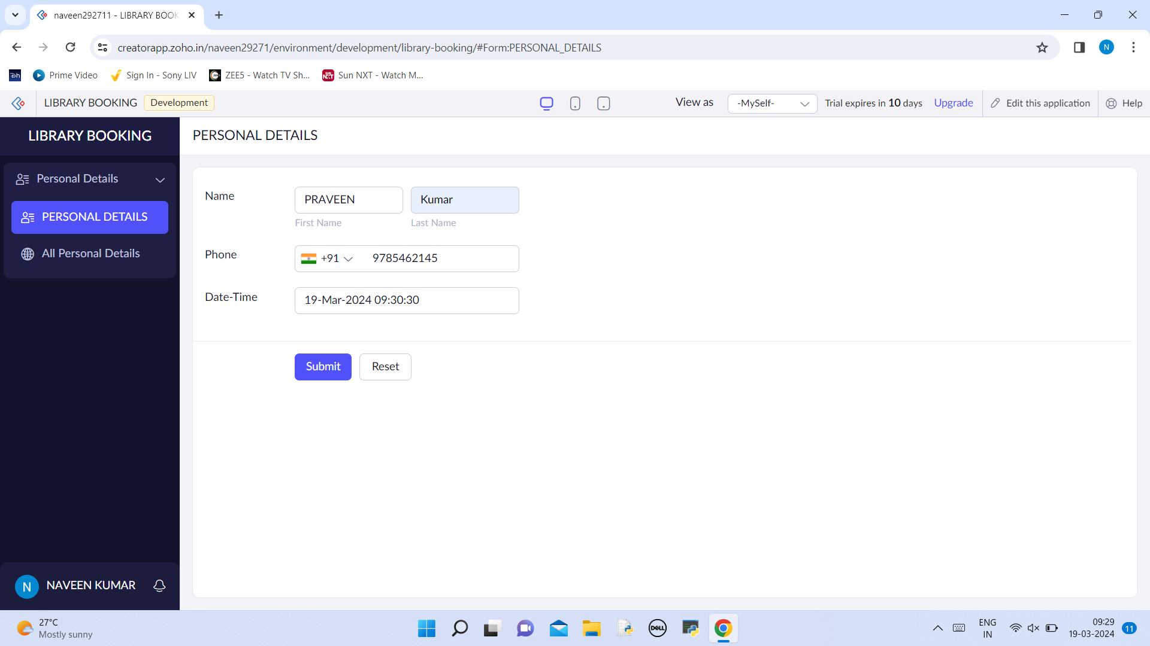

# DISPLAYING THE PERSONAL DETAILS LIST

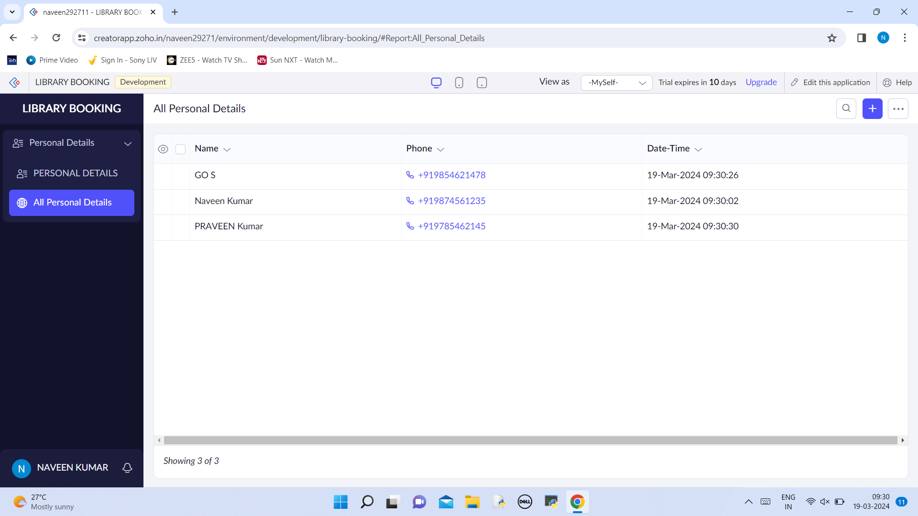

# CREATING THE BOOK DETAILS   
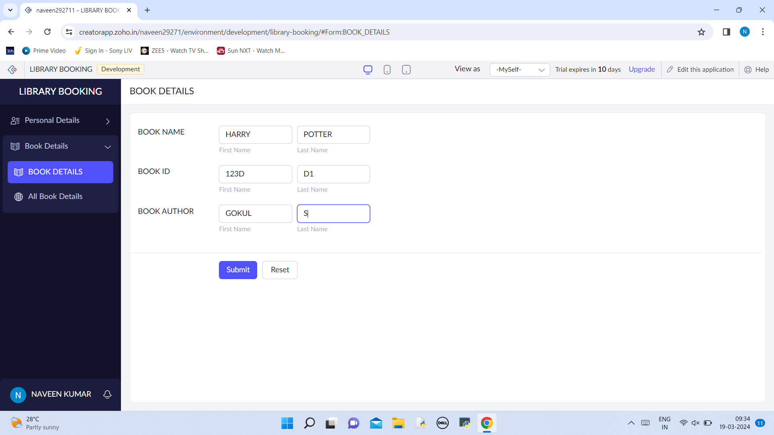

# DISPLAYING THE LIST OF BOOK DETAILS  
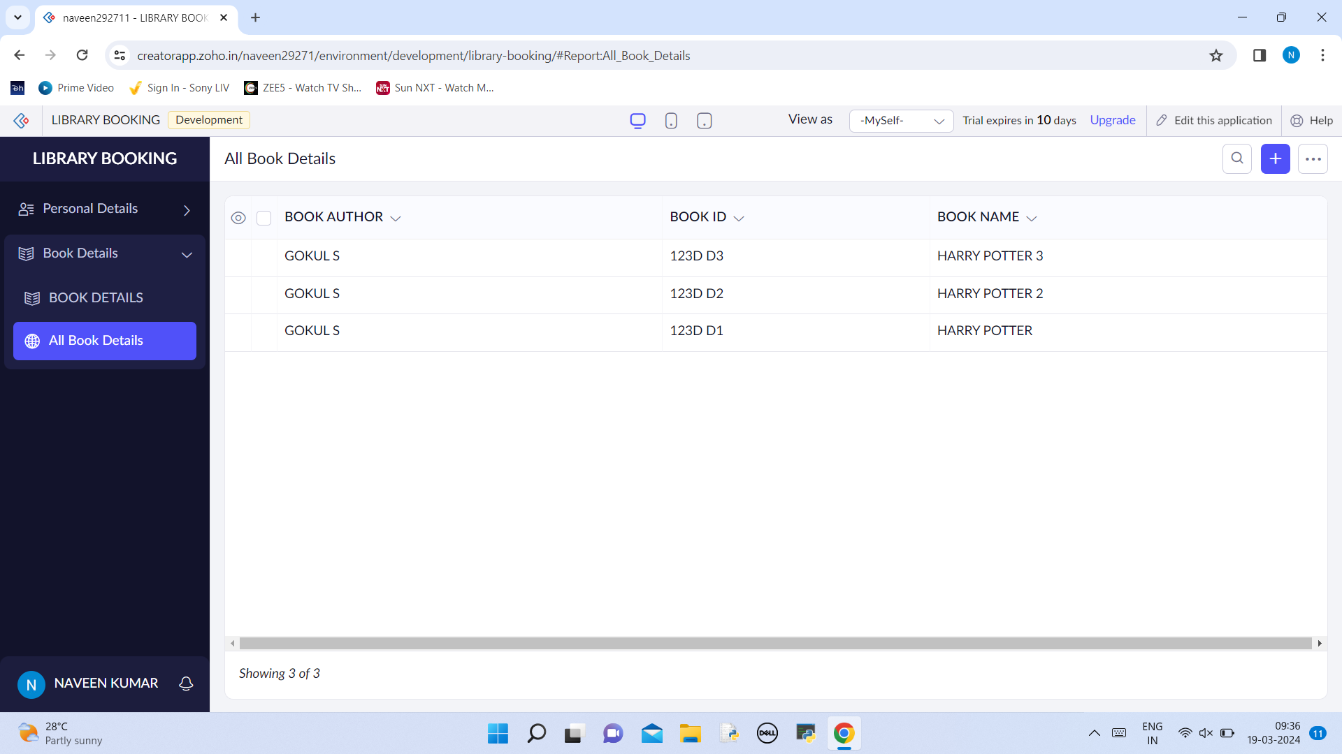

# RETURN DATE OF THE BOOK   
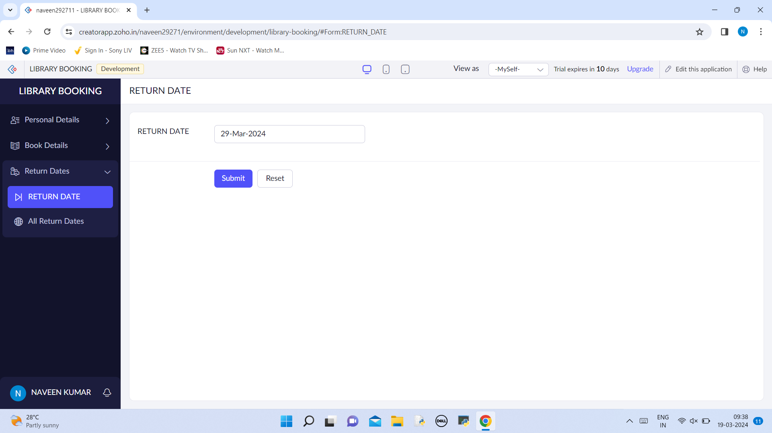

# LIST OF RETURNING THE BOOK   
